**Pharma Sales Dashboard**

**Sales(Task 1 to 4):-**

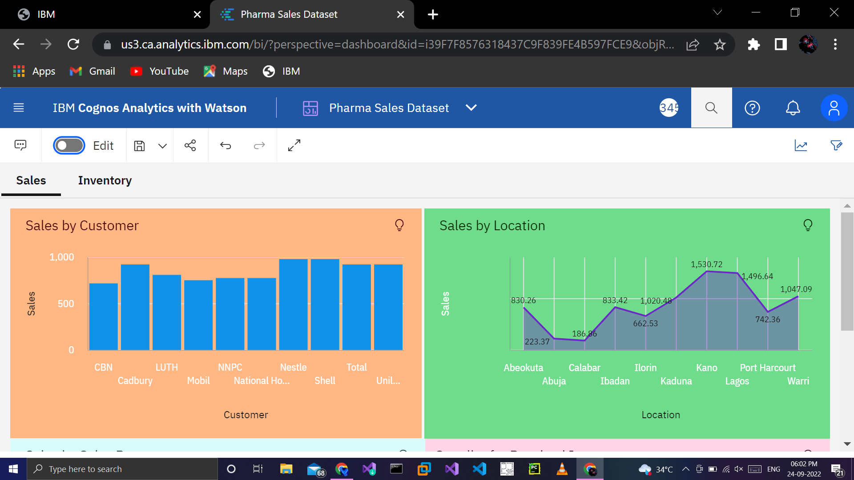

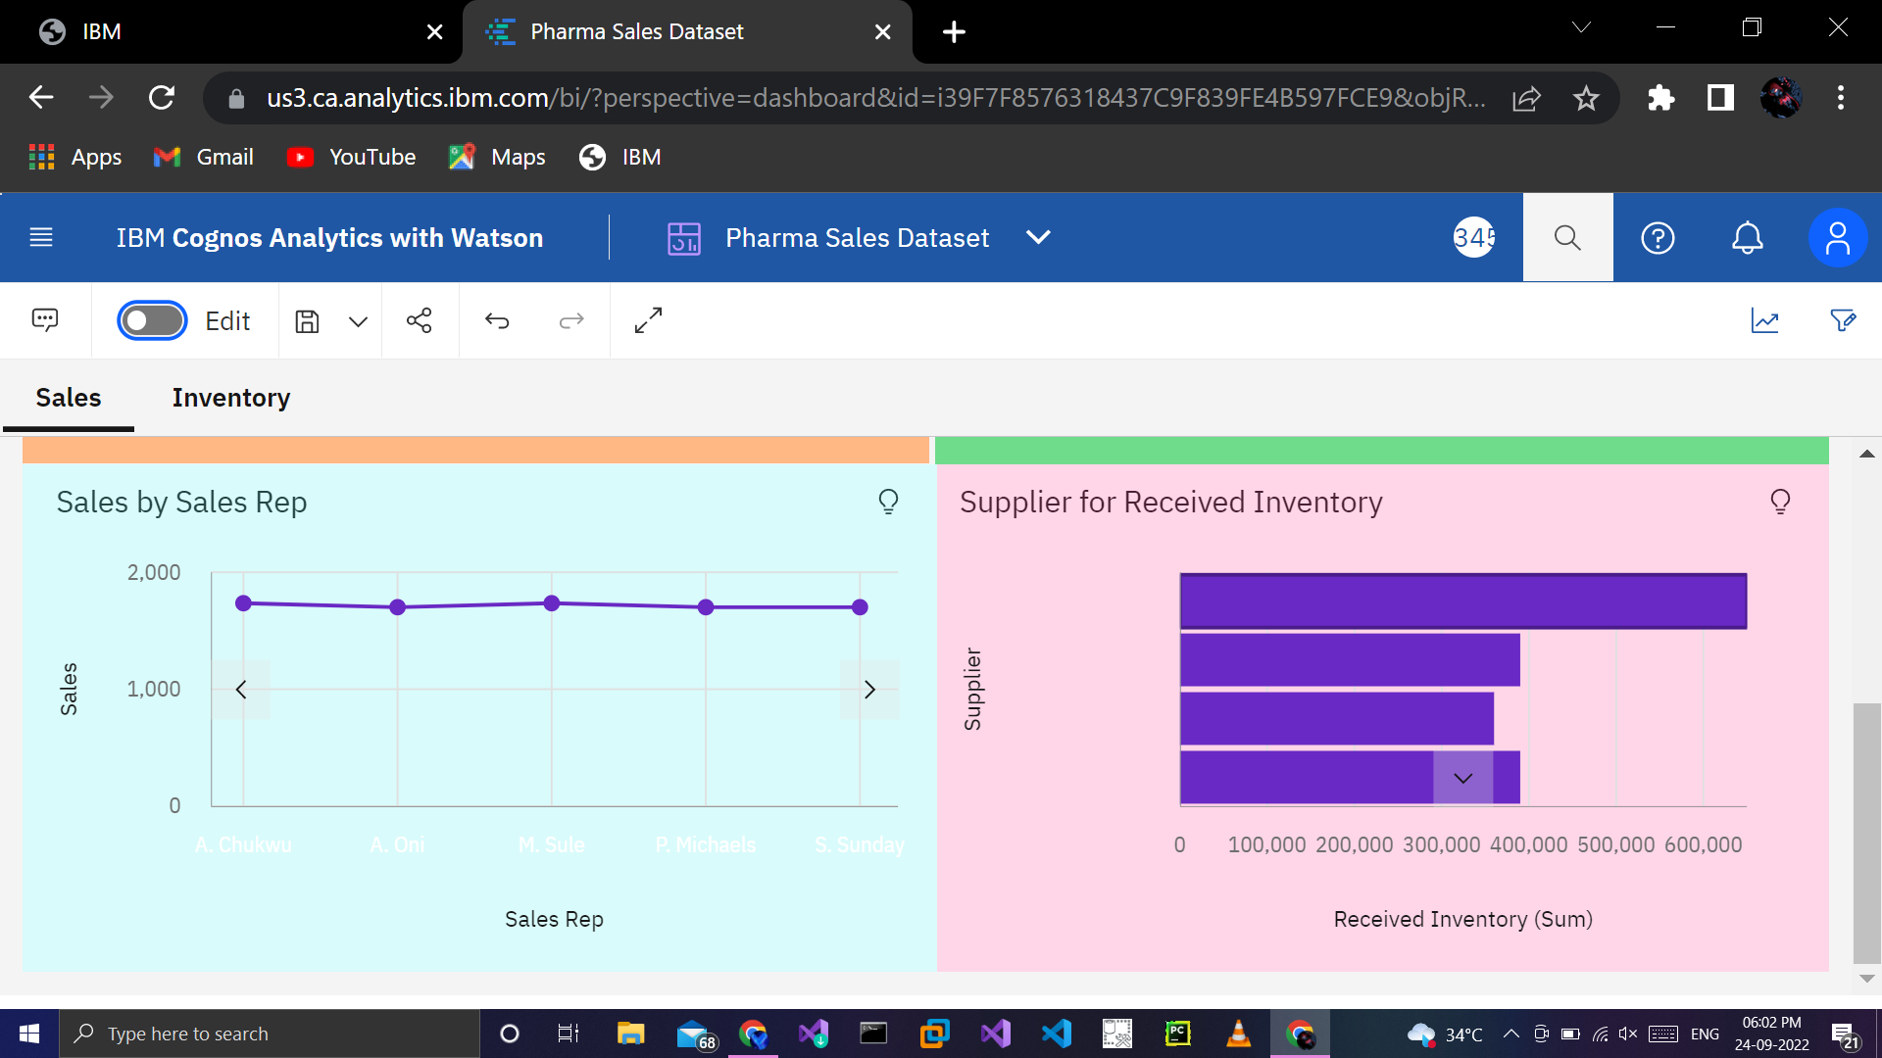

https://us3.ca.analytics.ibm.com/bi/?perspective=dashboard&pathRef=.my_folders%2FPharma%2BSales%2BDataset&action=view&mode=dashboard&subView=model000001836d0e0b6f_00000000

**Inventory(Task 5 to 8):-**

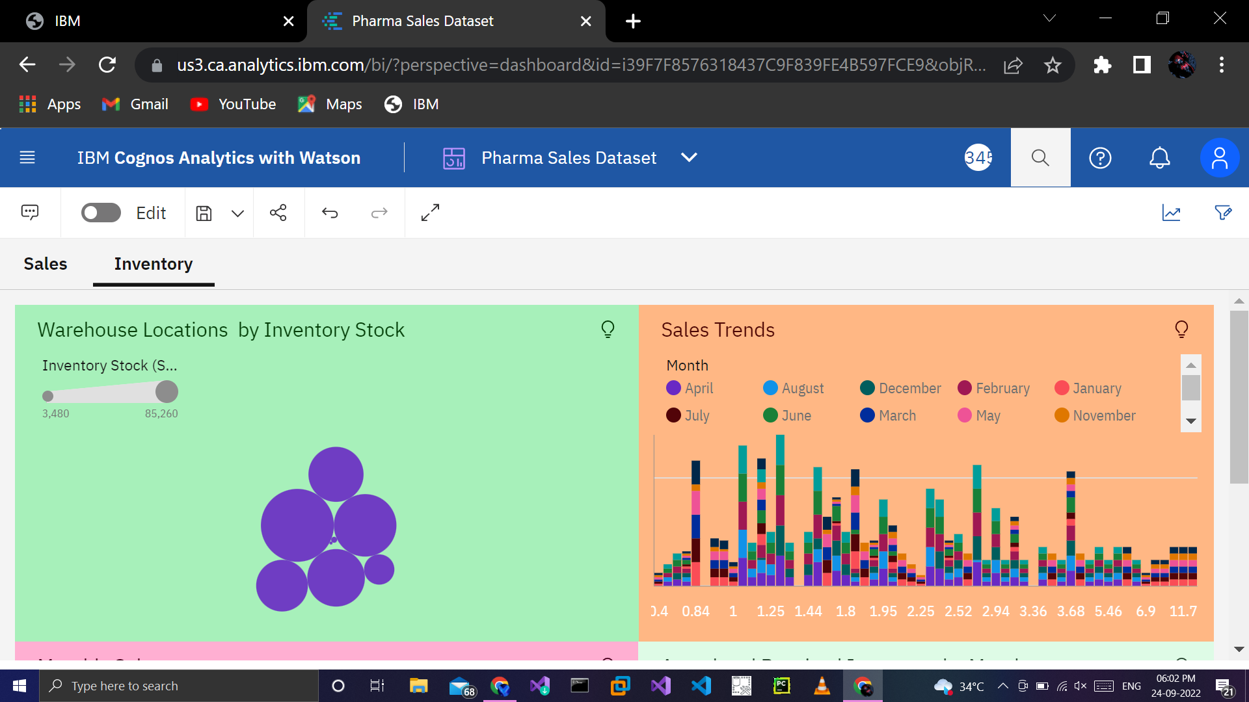

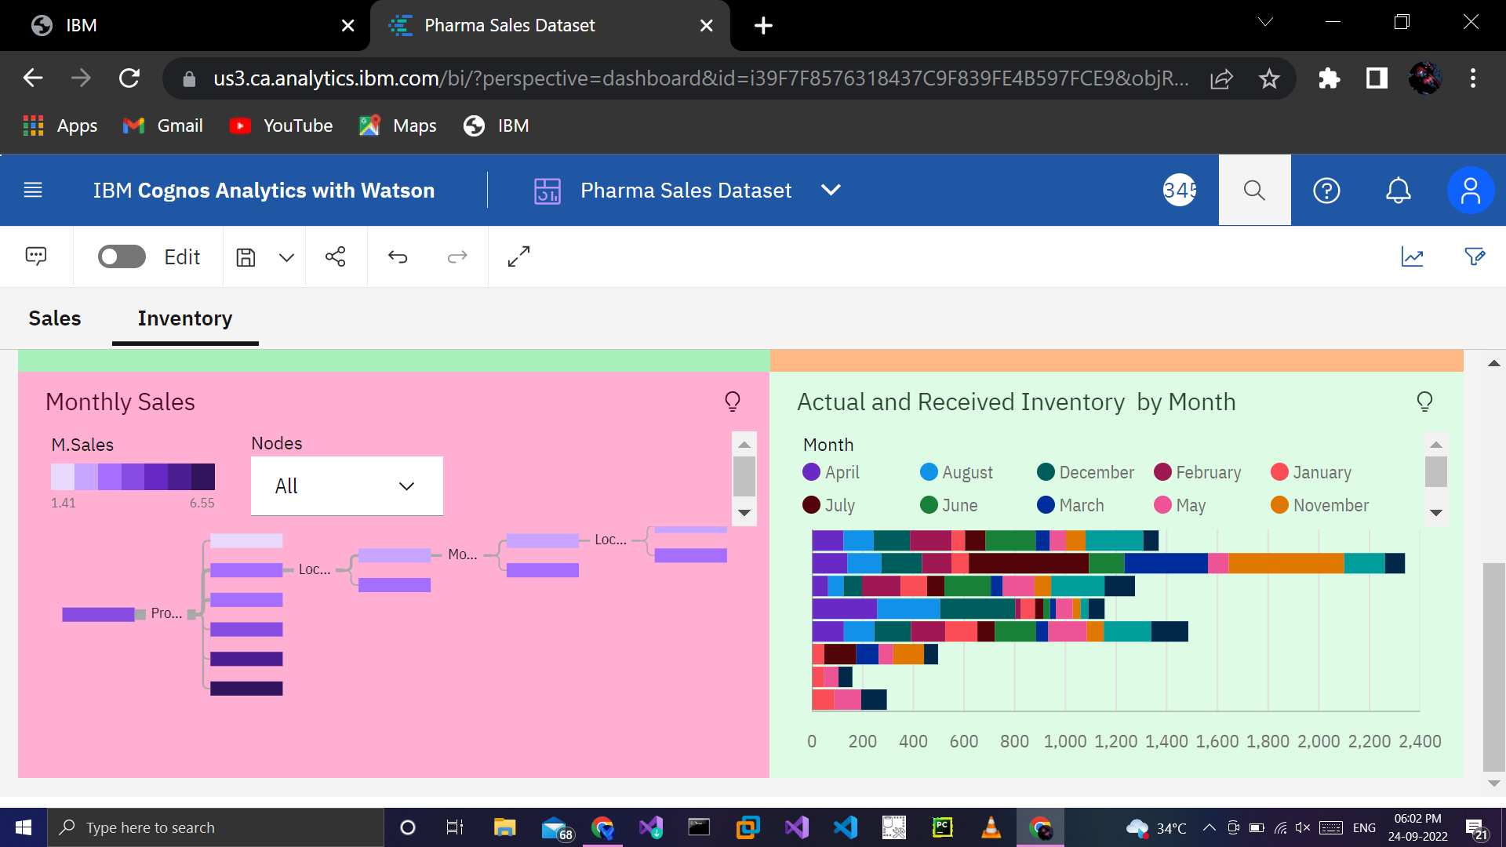

https://us3.ca.analytics.ibm.com/bi/?perspective=dashboard&pathRef=.my_folders%2FPharma%2BSales%2BDataset&action=view&mode=dashboard&subView=model000001836d1c7965_00000000